Softphone

1)Cloud Communications Requirements

**PayPal Integration:** We will integrate PayPal by that user can easily pay their bills at any time and make the calls right away.

**Audio Codec:** At the time of voice calls over the Internet or other digital networks, the voice has to be encoded into digital data, and vice versa. In the same process the data is compressed such that its transmission is faster and the calling experience is better.

**XMPP:** It is an open technology for real-time communication so, We will use this protocol for exchanging information and it allows either side to send data to the other asynchronously.

**SoftPhone:**In this we will use "nexmo" api to integrate it for calling functionality in the app through internet.

2)Features Demo List

Making Phone Calls:

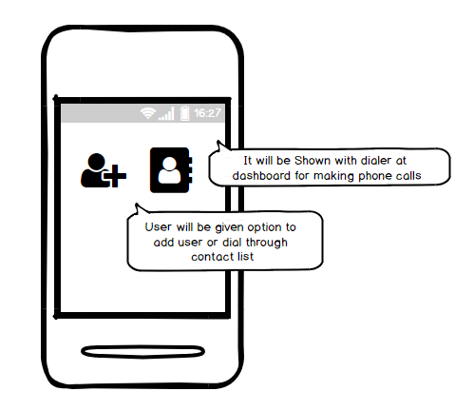

Reciveing Phone with nexmo Api

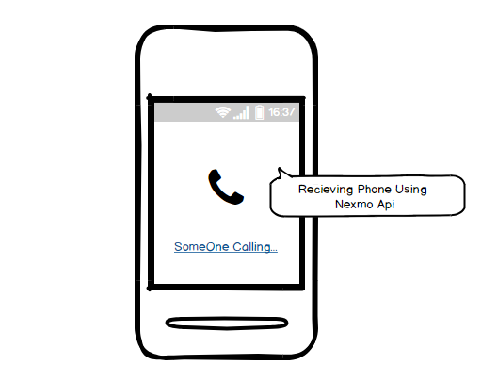

All network Support

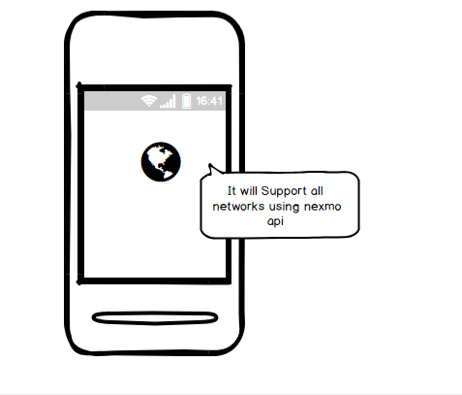

SendSms using Xmpp

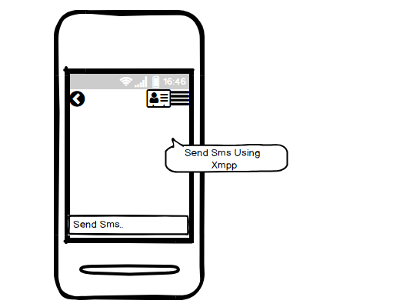

PayPal Integration For Transactions in app

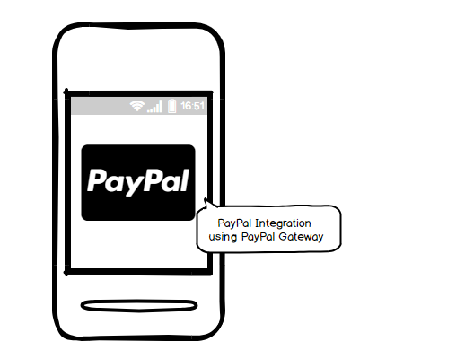

Support Executive:It will be handled by Nexmo for calling and chat for xmpp

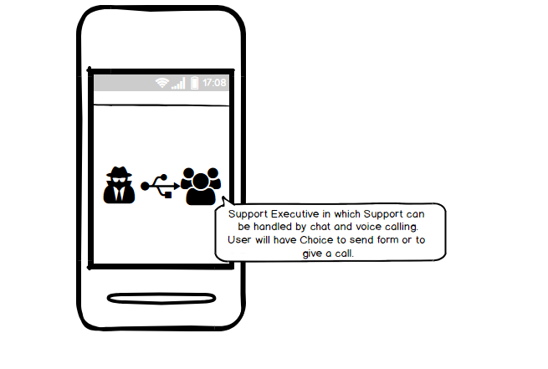

Call Forwarding Using Nexmo

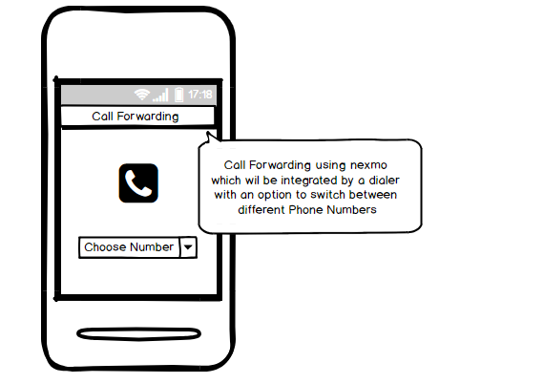

Call Detail Report:Save in LocalStorage or Cloud Storage According to Client Requirements.

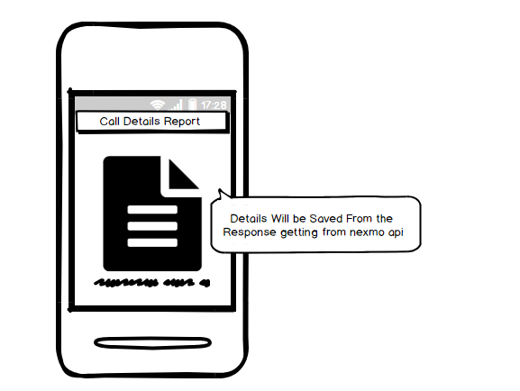

3) Add-On Feature list as Follow:

VoiceMail-:It will be integrated by voice having mic in app to record and make speech into text and send the email

Auto Responder:It can integrated with the Support Executive

Auto Fundng:It can be integrated with Payment Process in the app through Payment Gateway.

Porting Facility:Porting Facility can be done with importing the contact list.

4.Asssumptions:

All the Understanding Flow are given in this document as per content given by the client.Please let us know the if the flow is some what different.

The Feature Demo list is counted both for Desktop & Mobile App

5.Language Requirement:

1)Ionic Framework or Xamrin Framework for Building Mobile Application

2)Electron Integration with Angular 4 for Building Desktop App